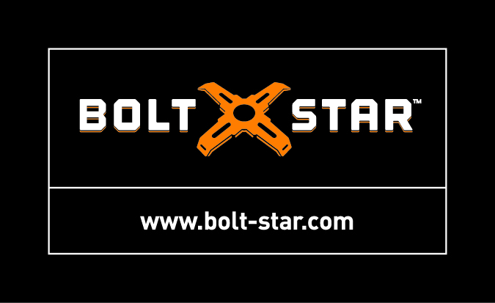
FAQ – BOLT STAR®
Q: How many BOLT STAR tools do I need for my job?
A: The answer to this question raises another question, that is “how many pole base foundations will you pour each day?” Answer: you only need enough BOLT STAR tools to cover your daily pour. Unlike wood templates, BOLT STAR can be re-used over and over again. Contractors with a large parking lot job full of bases will typically pour 8 to 10 pole bases a day – roughly the amount of concrete that is delivered in a 10-yard ready-mix truck. For example, if a project has 24 light pole bases to build and your goal is to complete the job in 3 days, you need only eight (8) BOLT STAR tools. Setup the first 8 bases, pour, wash down, set up the next 8 bases, call for inspection, pour, and then repeat again on day 3. Bam! You’re done.

Q: How many reuses will I get from the tool, i.e., how long will it last?
A: BOLT STAR is a very durable tool made of long lasting, industrial strength plastics. With proper care contractors have used the same BOLT STAR tools over and over again for up to 2 to 3 years. Some contractors spray the BOLT STAR tool with a bio-degradable release agent or non-stick formula. This makes cleanup easier too. If you decide to use a release agent, avoid using brands that are acid-based or contain other toxic chemicals.

Q: Is BOLT STAR strong enough for the rigors of concrete construction?
A: YES, without question. BOLT STAR tools have been proven reliable by professional contractors in the field under all conditions for over a decade. Industrial strength plastic materials are becoming more common in construction tools and on heavy equipment since they provide strength without rusting, and are lighter in weight and easier to clean up. In extreme stress testing designed to simulate the downward forces on BOLT STAR during a cast-in-place pour, product engineers hung a whopping 1,000-lbs off a 7-foot rebar cage wired to the cage tie slots at the end of BOLT STAR’s arms. This is so much weight that the rim of the forming tube collapsed at 800-lbs, not BOLT STAR! In further testing, the tool was driven over by a 6,000-lb SUV and it popped back up without damage.
Q: Is BOLT STAR adjustable?
A: Yes, for varying paper template specifications including bolt sizes up to 1-inch, 7” to 10” bolt circle diameters and 5” to 10” bolt square patterns. This adjustability is a big advantage BOLT STAR has over wood templates built custom for each specification. With adjustable bolt slots and pre-measured markings, changes in bolt circle diameter can be made in a few minutes.

Q: Can I fit two 2” conduits through the center opening?
A: The center opening of BOLT STAR is 4 1/8 inches ID, and each 2” conduit is approximately 2 3/8 inches in outside diameter. Thus, two 2” conduits will not fit through the center opening.
Suggested work around: there is a minimum 1 ½ inch vertical clearance from top of form to bottom of the BOLT STAR tool, so it is possible to cut the conduits about ½ inch below the bottom of the tool. Next, tape over the conduit openings. Conduits should still project at least 1” above the top of finished base, then add a coupler after the pour to extend the conduit.

Q: Our field crew cuts the forming tube onsite. Will Bolt Star still work if the rim of the tube is uneven, i.e., not a clean and level cut?
A: We recommend always setting forming tube in the hole with the machine cut edge UP. Cutting forming tube in the field is asking for problems. No need to increase the risk of bolts
found out of alignment and/or the top of base being finished on a slant. Use Bolt Star’s bubble levels to ensure straight bolts and level bases.

Q: Will BOLT STAR fit on the larger outer diameter tube that comes slipped over standard sized round concrete forming tubes?
A: YES, using the Xtender™ Adaptor. Manufacturers of round concrete forming tubes in some regions ship a standard size 18”, 24” or 30” tube that is nested within a larger outer diameter 19”, 25” or 31” tube. This is called “nested tube”. Tube manufacturers save on freight and storage costs. What’s deceiving is these larger outer tubes are labeled as being standard size. They are not. We designed the Xtender to snap on to the end of each BOLT STAR arm and extend it to fit the larger outer diameter 19”, 25” or 31” tube sizes. Xtender is interchangeable between the 18”, 24” and 30” BOLT STAR tools, and can be purchased together with BOLT STAR as a kit in the “BOLT STAR-Nested Tube Editions,” or separately as an accessory item

Q: Does BOLT STAR fit a square foundation form?
A: YES, using any BOLT STAR tool with the red Square Form Adaptor. The Square Form Adaptor can be purchased separately as an accessory and is interchangeable with BOLT STAR 18” (for 15” to 19” square), 24” (for 20” to 24” square) or 30” (for 24” and larger square foundations.

Q: Do you make a 16” or 20” BOLT STAR tool?
A: No, but we have a solution for the 16” and 20” round tube sizes. For the 16” round tube, use a BOLT STAR 18” with a red Square Form Adaptor and attach the assembled tool to the H-frame wood form mounted flush to the rim of the tube. For the 20” round tube, simply use a 24” BOLT STAR with a Square Form Adaptor attached to the H-frame wood form mounted flush to the rim of the tube. Check it out at www.bolt-star.com, PRODUCTS/Bolt Star Family of Tools.

Q: Will the BOLT STAR tool accommodate a 6 ¾” bolt circle diameter?
A: Yes, but only when using ¾” anchor bolts. With ¾” bolts at the smallest 7” bolt circle measurement on the BOLT STAR tool, the distance between center of bolts is exactly 6 ¾”.

Q: What assembly is required?
A: Very minor. Assembly involves snapping each arm on to the black hub, then inserting a small 1/4-20 x 1 ¼” bolt and nut through each of BOLT STAR’s four arms. The hardware is included with every BOLT STAR tool. Assembly instructions in English, Spanish and French are provided. The Xtender and Square Form Adaptor accessories slip up and snap on to the end of each BOLT STAR arm with a compression clip, no hardware fasteners required.

Q: What type of warranty comes with the tool?
A: 180-day warranty from date of purchase on factory defects in material only that are not due to ordinary wear and tear. Not covered are damage due to negligence or improper installation or operation, accident or other conditions which might cause the product to fail in other than normal use.

Q: Where is BOLT STAR made?
A: In the USA! All BOLT STAR tools are 100% manufactured in the United States by Bolt Star LLC based in Granite Bay, California.

Q: What is the BOLT STAR story?
A: BOLT STAR was invented by two electricians and an engineer. Tired of building wood templates and experiencing the inherent problems that come with that method, they one day decided, “there has to be a better way”. The inventors developed numerous sketches and designs over a ten-year period before deciding on the final design to be tested. The final phase involved subjecting prototypes to intensive field testing through a collaborative effort with Rex Moore Electric, an EC&M Top 50 electrical contractor. This straight feedback from electricians in the field was key to refining the tool into its final patented version.

Q: Who is the manufacturer of BOLT STAR?
A: Bolt Star LLC is a family-owned small business with headquarters in Granite Bay, California.
- Founded in 2012 by former construction company owners and industry professionals
- Bolt Star LLC designs, manufactures and distributes tools for the construction industry
- Mailing Address: 4120 Douglas Blvd. #306-527, Granite Bay, CA 95746-5936
- Contact: 1-844-380-STAR (7827) www.bolt-star.com

